**[How to enable incoming email on a document library](https://sharepoint.rackspace.com/learning/articles/Pages/SharePoint-2013--how-to-enable-incoming-email-on-a-document-library.aspx)**

1. On the home page of your SharePoint site open a document library.

2. At the top of the Document Library page, click **Library** to expand the ribbon.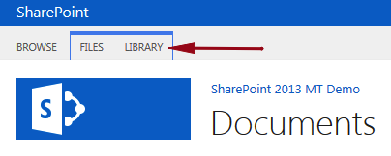

3. On the far right of the ribbon click **Library Settings**.  
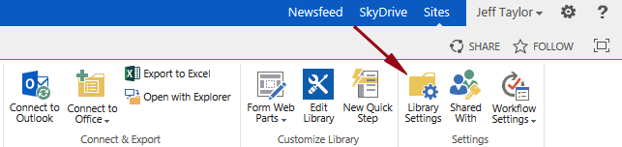

4. Under Communications click **Incoming e-mail settings**.  
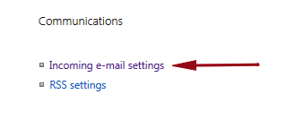

5. Where it says “Allow this document library to receive incoming e-mail?” click **Yes**.

6. In the E-mail address: section type what you would like the email address to be.  **Important**   
**note**: the **rackersmtp.raxsp.com** portion is cannot be modified.  
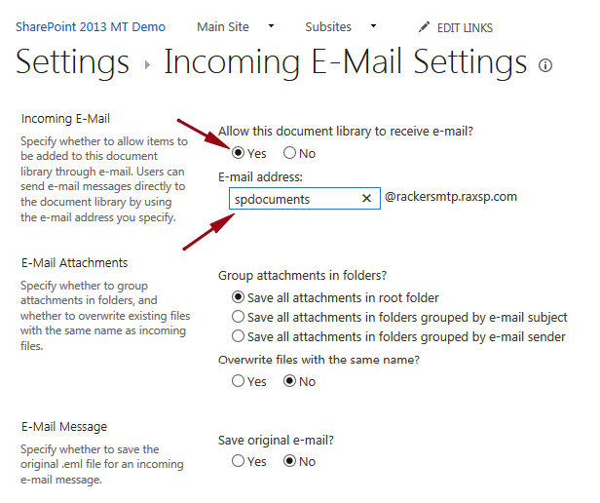

7. View the other settings you are able to modify, make additional changes as you see fit.  
  
8. Scroll to the bottom and click **OK**.  
  
The document library is now enabled for receiving e-mail.  To test this, simply send an email to the email address of the document library and after a few moments the email will appear.